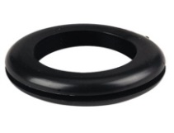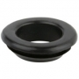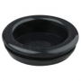

Material : PVC

AVAILABLE SIZES
20 mm
25 mm
32 mm
38 mm
40 mm
50 mm

ITEM DIMENSIONS
ITEM NAME | SIZE | O.D. | HOLE I.D.
OPEN GROMMET | 20 MM | 24.00 MM | 16.50 MM
OPEN GROMMET | 25 MM | 31.50 MM | 19.50 MM
SUPER OPEN GROMMET | 20 MM | 27.00 MM | 16.50 MM
SUPER OPEN GROMMET | 25 MM | 30.00 MM | 21.50 MM
BLIND GROMMET | 20 MM | 25.20 MM | -
BLIND GROMMET | 25 MM | 30.50 MM | -
SUPER BLIND GROMMET | 20 MM | 26.50 MM | -
SUPER BLIND GROMMET | 25 MM | 28.80 MM | -

